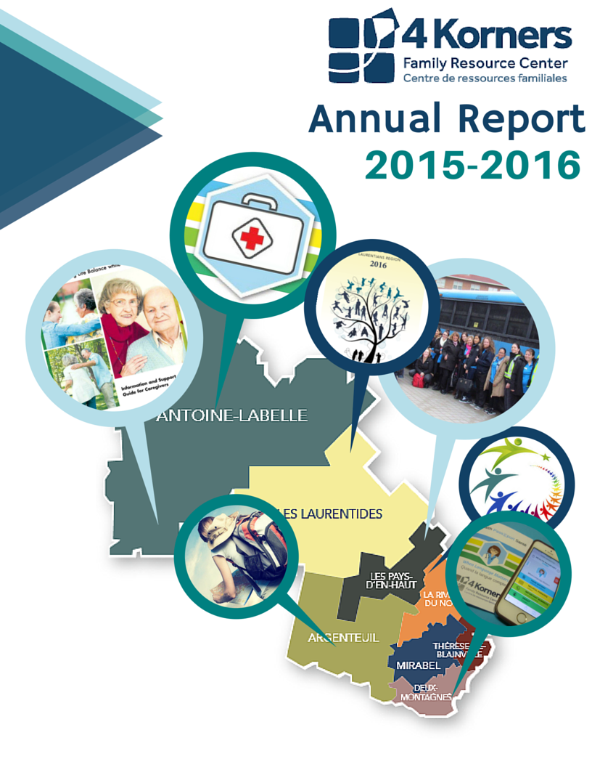

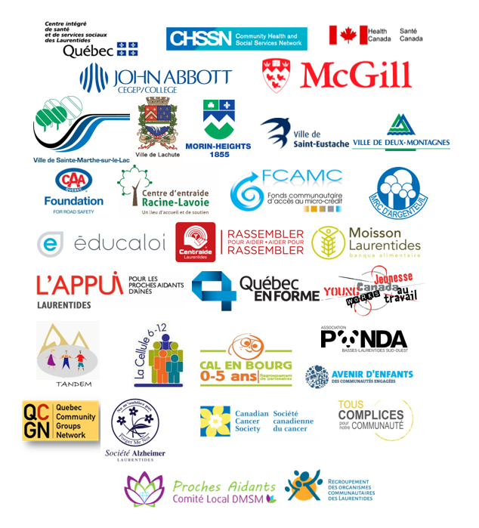Our project sponsors, funders and partners

Contents

A word from the President 2

A word from the Executive Director 3

Our Mission 4

Governance 5

The Staff 6

Programs and Services 7

Information and referrals 7

Total number of interventions at a glance 8

Networking in the Laurentians 9

Head Office in Deux-Montagnes 10

Satellite Office in Sainte-Agathe-des-Monts 12

Satellite Office in Lachute 13

In the MRC Thérèse-de-Blainville 13

Reaching the Laurentians 14

Sponsors, Supporters, Funders and Partners 2015-2016 19

Notes 21

\**Disclaimer: The views expressed herein do not necessarily represent the official policies of the funders, sponsors or partners.*

# A word from the President

It has been a year of excitement! The 4 Korners Family Resource Center has been able to work within our guidelines and be the "go-to organization" when people need help in accessing health and social services in English. A task that is not easily accomplished but with the support of our many partners we have been able to do so.

This past year we welcomed the Health Caravan, an event that was a huge success for the communities in our mandated area. We have broadened and expanded the network. French-speaking organizations and partners know who the 4 Korners are and how we can collaborate to reach common goals for the Laurentian communities. This is a direct result of our Executive Director, Lisa Agombar, and her hard work and dedication to building and strengthening our partnerships with the organizations and communities in our mandated territory.

The hard work and commitment of our staff has set in motion a lot of changes that will ensure the 4 Korners will be able to continue impacting, in a positive way, the everyday lives of seniors, children, and families. The community will continue to be able to rely on us by assisting them in finding the resources they need in English.

Since I began my involvement, we have always been blessed with strong volunteers. This year the word strong does not do them justice. A heartfelt thank you to all the volunteers and their dedication over the past year; we couldn't have done it without you!

The Board of Directors is committed to ensuring the success of the 4 Korners and accomplishing our mandated goal, which is to provide access to Health and Social Services resources to all people who need it in English. The decision to move our Head Office to the Ville de Deux-Montagnes’ Community Center allows us to strengthen our foundation and carry out our strategic direction. We firmly believe that the path we are headed in will set us up for success for many years to come. A change which will be different, it doesn’t mean that it is bad, just different.

I am looking forward to another year that will be filled with positive changes, equally challenging as they will be rewarding.

Sincerely,



Peter Andreozzi

President, Board of Directors

4 Korners Family Resource Centre

# A word from the Executive Director

Dear Community of the Laurentians and supporting regions,

It is with pride that I present our Annual Report for the 2015-2016 year.

A sense of pride comes from the opportunity to coordinate and facilitate the Laurentian English Services Advisory Networks (LESAN) of over fifty partners who serve the English community and meet regularly to exchange information and resources for the communities throughout the Laurentians. They are continuously devoted and invested in improving the access of information and resources in English. Our many Laurentian partners of organizations and associations who now say, “Let’s do this in English!” in an initiative, project or information tool reminds us of how unique the Laurentians are.

This year, we delivered some very exciting and interesting projects. Highlights of the year gone by have included Health information sessions for seniors, caregivers and families, a Health passport, The Quebec Community Groups Networks survey results of seniors living in the Laurentians, A Health Caravan touring the Laurentians, translations and dissemination of tools and resources in health and social services and law. Our new monthly newsletter increased subscriptions and continues to grow each month.

The many accomplishments are possible owing to the great work of all staff, volunteers and Board of Directors. The cornerstone of 4 Korners Family Resource Center success lies in the dedication of all those involved in its activities and we wish to express our heartfelt gratitude.

This continued commitment will allow 4 Korners to continue to strive in expanding our reach in the Laurentian community for all English speaking communities. As we undergo change and transition to our new location in the Ville de Deux-Montagnes Community Center we remain committed in offering information & resources to break isolation to those who know us and to those who are still to reach.

Sincerely,

cid:image001.png@01D1C55B.CAB488E0

Lisa Agombar

Executive Director

# Our Mission

# Governance

# The Staff

The knowledgeable staff at 4 Korners Family Resource Center, whether in Deux-Montagnes, Sainte-Agathe or Lachute, can help you find the appropriate resource every time.

A total of over 7,692 hours of work were completed in 2015-2016.

|  |  |  |
| --- | --- | --- |
| Name | Title | Project/grant |
| Agnes Noubicier | Social Worker | SAPA |
| Amanda Fougere | Executive Assistant | General operations* |
| Edith Ury | Coordinator | CHSSN : CHEP / SAPA |
| Ellen Holdaway | Kids Let’s Talk | Tandem 0-5 / Avenir d’enfants |
| Eren Dagdeviren | Kids Let’s Talk | Tandem 0-5 / Avenir d’enfants |
| Gabrielle Paquette | Tous Complices Project | Adaptation program CHSSN / Health Canada |
| Harry Bleeker | Custodian | General operations* |
| Joyce Piette | Book-keeper | General operations* |
| Joanne Lamarre | Coordinator/intervention worker | Cal-en-Bourg / Avenir d’enfants |
| Kim Nymark | Communications Director | CHSSN / Avenir d’enfants |
| Roemisheil Marcelino | Support worker | Cal-en-Bourg / Avenir d’enfants |
| Laura Young | Coordinator/intervention worker | CHSSN: Health Promotion Project / Cal-en-Bourg / Avenir d’enfants |
| Lisa Agombar | Executive Director | CHSSN: NPI, HPP and McGill, General operations* |
| Lyne Girard | Accountant | General operations* |
| Melanie Murray | Support worker | Cal-en-Bourg / Avenir d’enfants |
| Melanie Wilson | Coordinator | L’APPUI / McGill /CHSSN |
| Mona Helal | Animator | Tandem 0-5/ Avenir d’enfants |
| Shan Lee Sauve | Participant navigator | Young Canada Works |

*General operations funds include the CISSS des Laurentides’ PSOC (programme de soutien aux organismes communautaires), SAPA (soutien à l’autonomie des personnes âgées) and FRASLA (fonds régionales à l’accès aux services en langue anglaise), Centraide Laurentides, Éducaloi and donations from other sources that are not project specific.

# Programs and Services

## Information and referrals

The main role of the staff at 4 Korners Family Resource Center is to ensure that health and social services are accessible to members of the English Speaking Communities of the Laurentians. In this process the staff provides referrals and information in the English language. Health information is provided through the distribution of printed materials, information sessions held for the public and an online resource database.

When appropriate, individuals are informed of 4 Korners’ in-house programs that may meet their needs. In the case that 4 Korners cannot offer an appropriate in-house program, users are referred to community organizations or public institutions in the Laurentians that can offer support or aid in English.

4 Korners members can benefit from these services by phone, email or in person at any of the three offices in the Laurentians. In 2015-2016 there were 1,288 inquiries made by persons in the lower and upper Laurentians.

**A special thank you to all the volunteers and partners who contribute to achieving fair access to heath and social services for the vitality of the English Speaking Communities.**

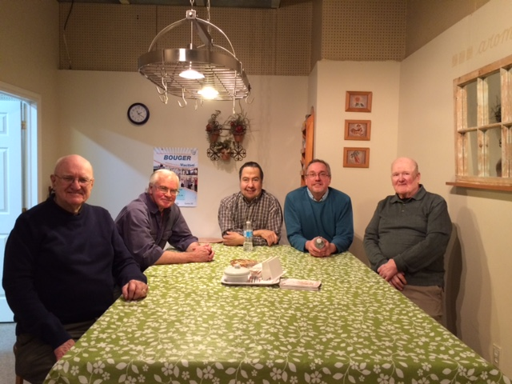

*The senior men’s cooking group.*

## Total number of interventions at a glance

The table below provides an overview of the number of interventions made possible through the various programs and projects offered by 4 Korners in 2015-2016, 1,288 interventions in total. Over 2, 360 individuals benefitted from programs, services, information and referrals in English. More than 1,434 volunteer hours contributed to making this possible. 113 people renewed their membership in the 2015-2016 year.

# Networking in the Laurentians

4 Korners Family Resource Center, through a grant from the CHSSN (Community Health and Social Services Network) and Health Canada, sponsors a network called the Laurentian English Services Advisory Network (LESAN).

**LESAN** is a network of English-speaking people and their organizations and associations that has as its mission to improve access to services and, in particular, health and social services in their language. It enables the English-speaking community to establish common goals and be in a position to speak with one voice to promote improved services in English.

**LESAN** members are primarily volunteers and representatives of local and regional community organizations and institutions. Members of the LESAN committees sit at various roundtables throughout the region to communicate the needs of the English-speaking community and to bring information to the English-speaking community about services in English.

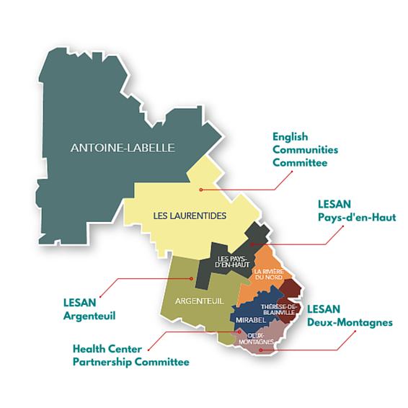In 2015, a **Communication Committee,** consisting of representatives from four of the five LESAN committees was created to develop a comprehensive communication plan. Once the communication plan was set in place, it allowed for an improved flow of information, support and solidarity among the LESAN groups. The Committee also created a complete communication kit, designed to reach and inform individuals, organizations and institutions as well as the population at large.

## Head Office in Deux-Montagnes

In the MRC of the Lac-des-Deux-Montagnes

|  |  |  |
| --- | --- | --- |
| **Activity** | **Health Impact** | **Number of interventions** |
| **Coordinate and facilitate the LESAN Deux-Montagnes** | Partners work together to improve access to health and social services in English for all. | Met 7 times  with an average of 8 partners. |
| **CAA Quebec Foundation: *Driving, is it as Safe as it used to be?*** | Increased knowledge of resources available in English. | One session attended by 10 individuals. |
| **Éducaloi’s “*Lets Talk Law in the Laurentians”*** | Increased knowledge of resources available in English. | One session attended by 14 individuals. |
| **Good Food Box** | Improved access to healthy choices and an increase in food security within the community. | An average of 17 people received Good Food Boxes over 22 weeks. |
| **Information Sessions for Caregivers** | Increased access to information in English. | 6 presentations were attended by an average of 13 individuals. |
| **Kids Let’s Talk** | Parents have tools to support their child’s (aged 0 to 5) development. | An average of 5 families met for 16 weeks. |
| **Reassurance Calls** | Support for seniors living alone, prevention or early intervention, improved mental health. | An average of 28 calls made per week for 52 weeks. |
| **Roundtables** | Improved access to health and social services in English for all through strengthened partnerships | 6 to 8 roundtables that meet approximately 8 times a year. Each roundtable has on average 8 to 10 partners. |
| **Senior Men’s Cooking Group** | Reduced isolation, increase of knowledge of healthy choices, improved mental and physical health. | An average of 4 senior men attended for 29 weeks. |
| **Scrapbooking** | Reduced isolation, improved memory, improved fine motor skills. | An average of 6 seniors for 23 weeks. |
| **Support for Caregivers** | Improved mental health and psychosocial support in English. | An average of 3 caregivers per month for 10 months. |
| **Tai Chi** | Improved physical and mental health. | An average of 3 participants per week for 26 weeks. |
| **Tous complices pour la communauté** | Adapted project for youth and English speaking community contributes to identifying and sharing their needs. Participants become active members of their community. | Reached approximately 150 individuals. |
| **What’s for Dinner?** | Parents have increased tools and knowledge to make healthy lifestyle choices for themselves and their families. | An average of 4 families met weekly for 22 weeks. |
| **Workshops for caregivers** | Caregivers have tools to support their loved one and maintain their own health. | An average of 5 caregivers attended two seven -week workshops. |
| **Yoga for the rest of us** | Reduced isolation among seniors, improved physical and mental health. | An average of 9 seniors per session for 51 weeks, 3 times a week. |
| **Viactive** | Reduced isolation among seniors, improved physical and mental health. | An average of 5 participants per week for 14 weeks. |

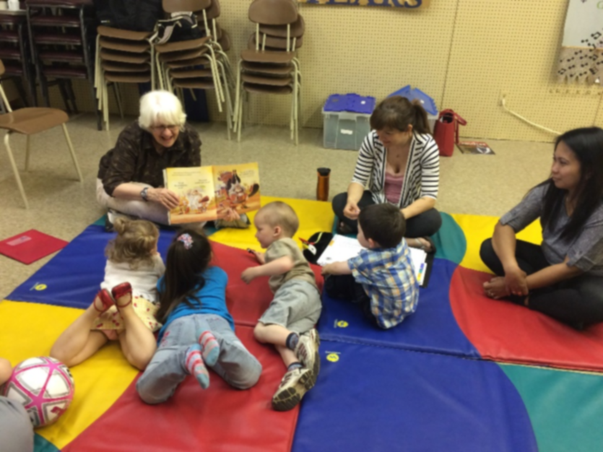

*Story time: Ellen and Eren animating the Kids Let’s Talk program.*

## Satellite Office in Sainte-Agathe-des-Monts

In the MRC des Laurentides and the MRC Pays-d’en-Haut

|  |  |  |
| --- | --- | --- |
| **Activity** | **Health Impact** | **Number of interventions** |
| **Coordinate and facilitate the English Communities Committee** | Improved access to health and social services in English for all through strengthened partnerships. | Met 4 times with an average of 7 partners. |
| **Coordinate and facilitate the LESAN Pays-d’en-Haut** | Improved access to health and social services in English for all through strengthened partnerships. | Met 5 times with an average of 8 partners. |
| **Coordinate and facilitate LESAN communication committee** | LESAN networks work together to improve access to health and social services in English for all. | 3 meetings with 4 representatives, one from each LESAN committee. |
| **Éducaloi’s “*Lets Talk Law in the Laurentians”*** | Increased knowledge of resources available in English. | 43 individuals attended one conference. |
| **Playgroup (Family Zone)** | Reduced isolation among families and model activities for children aged  0 to 5 years old. | An average of 3 families met weekly for 36 weeks. |
| **Roundtables** | Improved access to health and social services for all ages. | Met 42 times with a total of approximately 90 partners. |

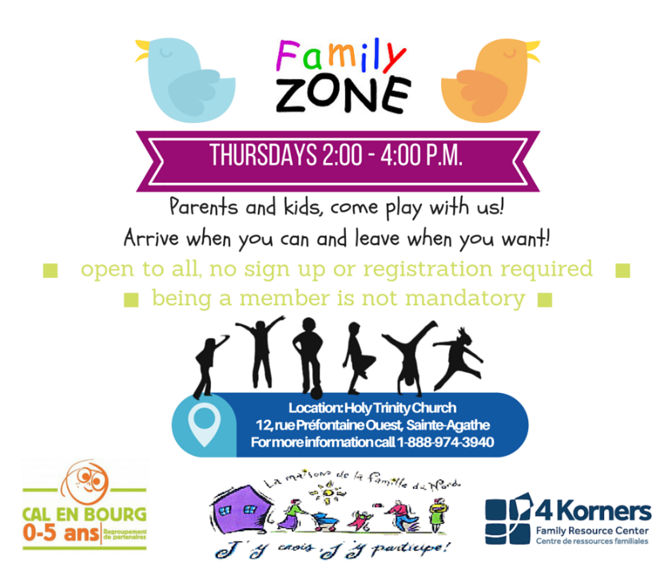

## Satellite Office in Lachute

In the MRC Argenteuil

|  |  |  |
| --- | --- | --- |
| **Activity** | **Health Impact** | **Number of interventions** |
| **CAA Quebec Foundation: *Driving, is it as safe as it used to be?*** | Increased knowledge of resources available in English. | 20 individuals attended one conference. |
| **Coordinate LESAN Argenteuil** | Improved access to health and social services in English for all through strengthened partnerships. | Met 6 times with an average of 6 partners. |
| **Éducaloi’s “*Lets Talk Law in the Laurentians”*** | Increased knowledge of resources available in English. | 18 individuals attended one conference. |
| **Jog Your Mind** | Maintains seniors’ cognitive vitality. | 8 individuals met weekly for 10 weeks. |
| **Information sessions for caregivers** | Increased information available to caregivers in English. | Three sessions were attended by a total of 45 individuals. |
| **Workshops for caregivers** | Increased information and support available to caregivers in English. | An average of 5 caregivers attended two seven-week workshops. |
| **iPad courses for seniors** | Increased knowledge to access various health and social services information sources. | An average of 10 participants met weekly for 4 weeks. |
| **Roundtables** | Improved access to health and social services in English for all through strengthened partnerships. | 4 roundtables that meet 8 -10 times a year. Total of approximately 50 partners. |
| **Videoconferencing** | Increased knowledge about various health topics for individuals of all ages. | An average of 14 participants attended 8 conferences. |

## In the MRC Thérèse-de-Blainville

|  |  |  |
| --- | --- | --- |
| **Activity** | **Health Impact** | **Number of interventions** |
| **Rosemère:** Information sessions for caregivers | Increased information available to caregivers in English. | 4 individuals attended one information session. |
| **Blainville:** Comité pour proches-aidants de Blainville | Improved access to health and social services in English for all through strengthened partnerships | Met 2 times with  8 partners |

## Reaching the Laurentians

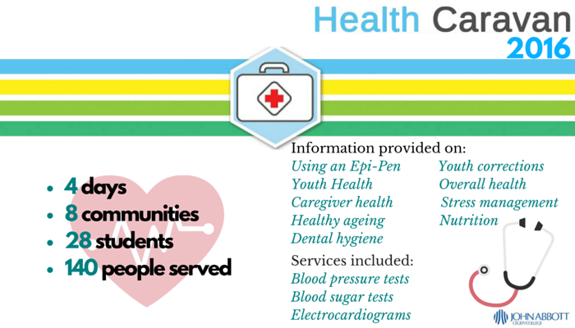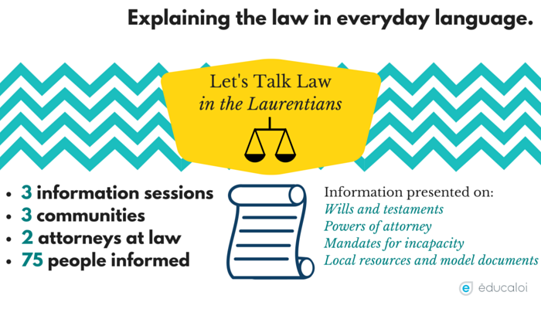The mission of the organization is to ensure improved access to services in English throughout the entire Laurentian region. Though there are currently three physical spaces where people may receive services, inquiries come from all parts of the Laurentians. In addition, partnerships extend beyond the three offices and result in activities in various parts of the region.

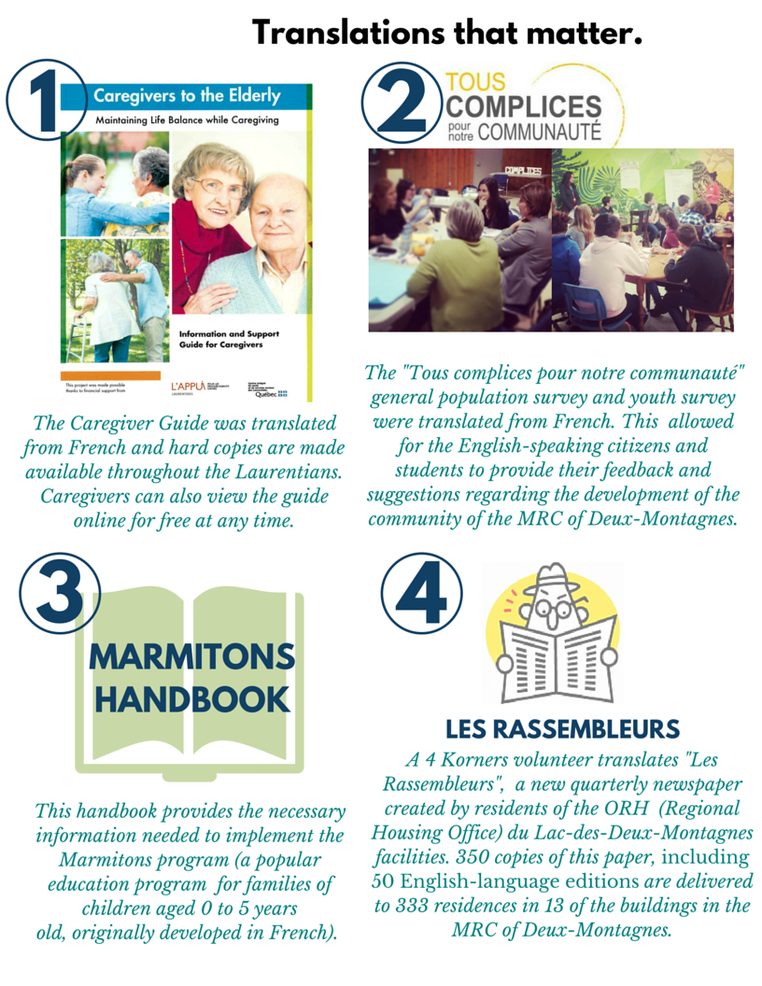

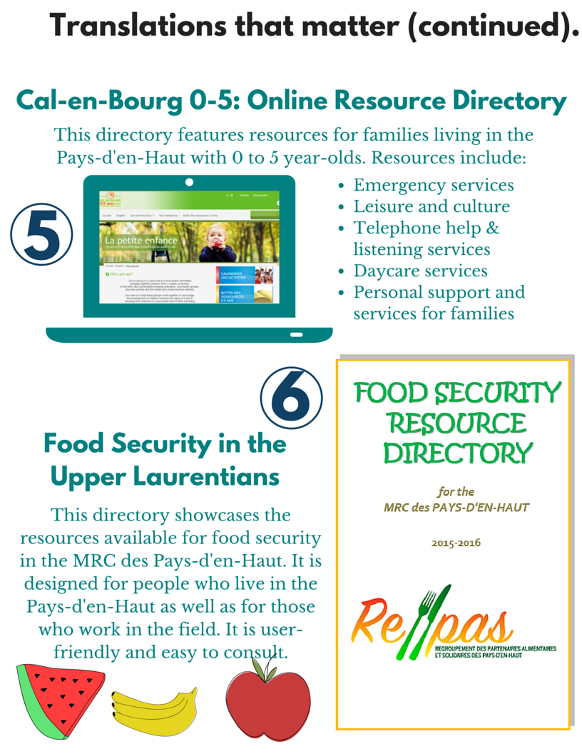

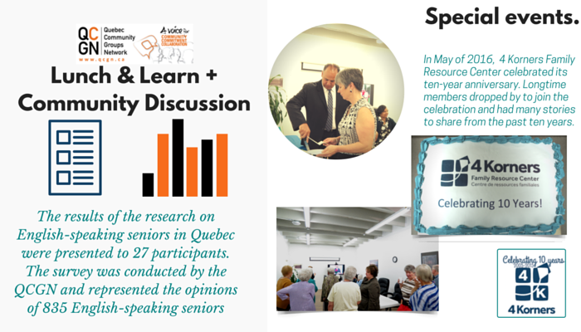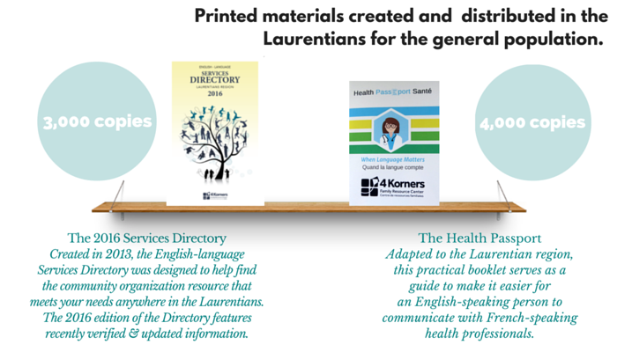

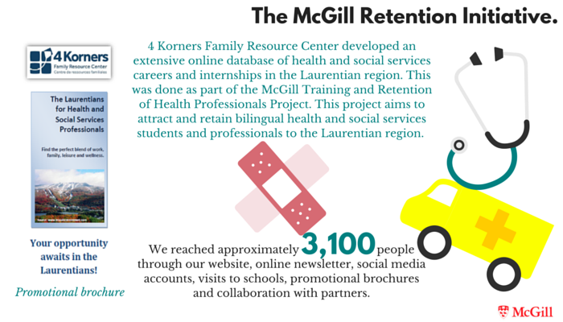

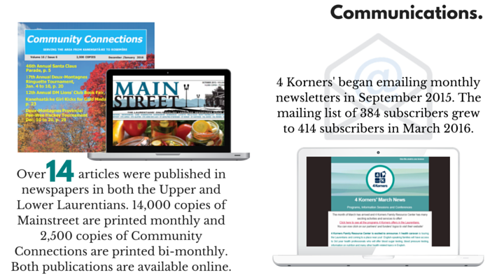

# Sponsors, Supporters, Funders and Partners 2015-2016

|  |  |
| --- | --- |
| Alzheimers Society of the Laurentians | |
| Arundel Elementary School | |
| Avenir d’enfants | |
| Board of directors of the CISSS des Laurentides | |
| C.E.S.A.M.E. | |
| Caisse Desjardins de  Saint-Eustache-Deux-Montagnes  CAA Foundation | |
| Cal-en-Bourg 0-5 | |
| Canada Revenue Agency | |
| Canadian Cancer Society | |
| Catholic Women’s League of Canada | |
| CENTRAIDE Laurentides | |
| Centre d’Action bénévole solidarité Argenteuil | |
| Centre d’entraide Racine-Lavoie | |
| Centre intégré de santé et des services  sociaux des Laurentides | |
| City of Deux-Montagnes | |
| City of Morin Heights | |
| Comité des proches aidants Argenteuil | |
| Comité des proches aidants Deux-Montagnes | |
| Comité des proches aidants Thérèse De Blainville | |
| Community Connections | |
| Community Health and Social Services Network | |
| Community Learning Center Lachute | |
| Community Learning Center Ste-Agathe | |
| Coop Bon-Ménage | |
| Coop Coup de Pouce Argenteuil | |
| Dépannage St-Agapit | |
| Deux-Montagnes Lions Club  Deux-Montagnes regional police department | |
| Éducaloi | |
| English Communities Committee | |
| Équité Santé Basses-Laurentides  Fonds communautaire d’accès au micro-crédit | |
| Fondation Médicale Pays-d’en-Haut – des Sommets | |
| Fonds d’Emprunts des Laurentides | |
| Groupe relève pour personnes  aphasiques des Laurentides | |
| Health Canada | |
| Health Center Partnership Committee | |
| Heritage Social Club  John Abbott College  Kanesatake Health Center | |
| Quebec Community Groups Network | |
| L’APPUI des Laurentides | |
| L’Éveil | |
| L’Oeufrier | |
| La Farandole | |
| Lake of Two Mountains High School | |
| Laurentian Club of Canada | |
| Laurentian Elementary School | |
| Laurentian Regional High School | |
| Le Carrefour Péri-Naissance Saint-Eustache | |
| Les Artisans de l’Aide | |
| Les Petits Frères | |
| LESAN Argenteuil  LESAN Deux-Montagnes | |
| LESAN Pays-d’en-Haut  Mainstreet Newspaper | |
| Maison de la Famille Argenteuil | |
| Maison de la Famille du Nord | |
| Maison des jeunes Deux-Montagnes  Maison du Citoyen Deux-Montagnes | |
| Masonic Foundation | |
| McGill University | |
| Morin-Heights Elementary School  Morin-Heights St-Eugene’s Church | |
| Mountainview Elementary School | |
| MRC Argenteuil | |
| PANDA BLSO | |
| Petite Maison Pointe-Calumet | |
| PRISME Lutte contre la dépendance  Portail Lac2M | |
| Québec en Forme Argenteuil | |
| Québec en Forme Deux-Montagnes | |
| Sainte-Agathe Academy | |
| Seniors Action Québec | |
| Seniors Heritage Club | |
| Sir Wilfred Laurier School Board  Société de développement de Saint-Eustache | |
| Sur les ailes des artisans | |
| Table 0-6 Pays-d’en-Haut | |
| Table 3e âge Deux-Montagnes | |
| Table Consultation Régional Aînés Laurentides | |
| Table de jeunesse des Sommets | |
| Table jeunesse 6-12 Deux-Montagnes | |
| Table jeunesse Argenteuil | |
| Table régionale des aînés d’Argenteuil | |
| Table régionale des aînés des Laurentides | |

TOPS

# Notes

